W45: Open Refine
Made on Monday 9th November 2020. Working with Andreas and Jakob. First, we read all the questions, though about them, and then discussed each question in detail at a time, coming up with results as we go. Each solution has been cleaned up and rewritten after the groupwork was done.
Question 1: Answer the question of: "What are basic principles for using spreadsheets for good data organisation?" (no more than 250 words)
The basic principles of spreadsheet data organization can be summarized by the term “Tidy Data”. The following quote describes the term in greater detail:” Tidy datasets are easy to manipulate, model and visualize, and have a specific structure: each variable is a column, each observation is a row, and each type of observational unit is a table.” In other words – each type of data is clearly labeled, easy to understand, and easy to work with.
Question 2: Does OpenRefine alter the raw data during sorting and filtering?
I think not. The raw data should never be altered unless you specify it to. Sorting and filtering is not data manipulation. It is just rearranging the raw data to get an easier overview of the data.
Question 3: Fix the interviews dataset in OpenRefine enough to answer this question: "Which two months are reported as the most water-deprived/driest by the interviewed farmer households?"
In order to find the two months that are reported as the most water-deprived/driest, the following expressions are used on the “months_no_water” column:
value.replace("[","") and value.replace("]","") is used to remove the brackets.
value.split(";") is used to seperate the values so they can be counted individually.
Value.replave(” ”,””) is used to remove any leftover space between the values.
All the months are then sorted by count: The most water-deprived/driest months are October September.
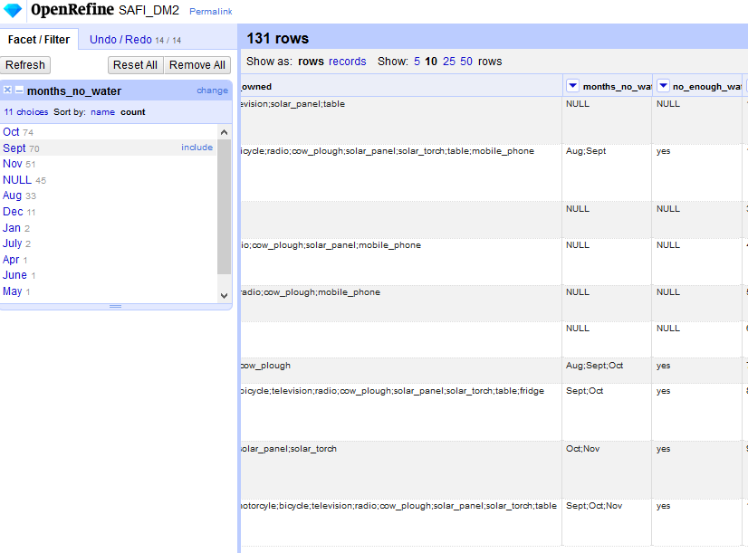

Question 4: Finish the tutorial and report what village *you* think hides behind the number '49'.
I think village number 49 is Chirodzo because the latitude and longitude of 49 matches with Chirodzo, and it matches in interview date.

W47: Start with R
Made on Monday 23th November 2020 (same day as hand in). Working with Jakob and Andreas. First, we read all the questions, thought about them, and then discussed each question in detail at a time, coming up with results as we go. Each solution has been cleaned up and rewritten after the groupwork was done.

Question 1: Use R to figure out how many elements in the vector below are greater than 2 . (You need to filter out the NAs first)
rooms <- c(1, 2, 1, 3, 1, NA, 3, 1, 3, 2, 1, NA, 1, 8, 3, 1, 4, NA, 1, 3, 1, 2, 1, 7, 1, NA)

The following information is stored as a vector like the string above.
Then the following line is used to create a new vector with the NA’s sorted out:
roomsSort <- rooms[!is.na(rooms)]
The following line is used to choose every number greater than 2, which is 3 3 3 8 3 4 3 7: roomsSort [roomsSort>2]

Question 2: What is the average number of rooms (result of running mean() function) in the above 'rooms' vector? Again, best remove the NAs first.
The function mean(x) is used on the roomSort to find the average: mean(roomsSort) which is mean(roomsSort)

Question 3: What type of data is in the 'rooms' vector? What function helps you determine the answer?
The following function is used to determine the type of data in rooms: str(rooms) and the output is num [1:26] 1 2 1 3 1 NA 3 1 3 2….
To make sure that the “NA” is accepted as num type, the same function is used on roomSort, which had the “NA” removed, and the result is: num [1:22] 1 2 1 3 1 3 1 3 2 1…
Screenshot of the code used for the 3 above exercises:
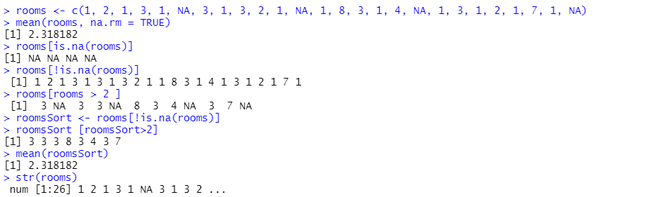
Question 4: In this Blackboard submission, list the URL leading to the screenshot in your github repository.
URL listed to GitHub is listed here:
https://github.com/Digital-Methods-HASS/au636152_Soerensen_Niclas

Tidy Data, page 1, line 4-6

